
HOW TO USE THE TEMPLATES IN MICROSOFT WORD or POWERPOINT:
- select the logo sample that matches the length of your community name
- paste into a new document
- double click on the sample name, delete the sample text, type in your community name
- save the document as a pdf
- import your new logo as art (click Insert, Photo, Picture from file, and select your pdf logo) into your Word file, use the crop tool to crop out extra white around logo

IMPORTANT RULES TO FOLLOW:
- Font is Arial Narrow Bold all caps, with normal spacing.
- To change text lines on font, click “format”, “font”, “text effects”, “text line”. Choose white, click on weights & arrows and enter point size:
- Font sizes larger than 30 pt. should have a white rule of .9 pt.
- Font sizes from 30 pt. to 20 pt. should have a white rule of .7 pt.
- Font sizes under 20 pt. use a white rule of .4 pt.
- Name should not exceed the width of the logo type.
- Spacing at the top of the logo should match the spacing at the bottom of the logo.

FOR THE COMBINED LOGOS :
Font: Arial Narrow Bold, all caps
1 line: Approx. 16 pt.
2 lines: Approx. 14 pt.
3 lines: Approx. 11 pt.

WORKING WITH A DESIGNER OR PRINTER:
If you work with a designer, send them all files and ask them to use the “Adobe AI” art files as templates to create your logo in Adobe Illustrator or InDesign.

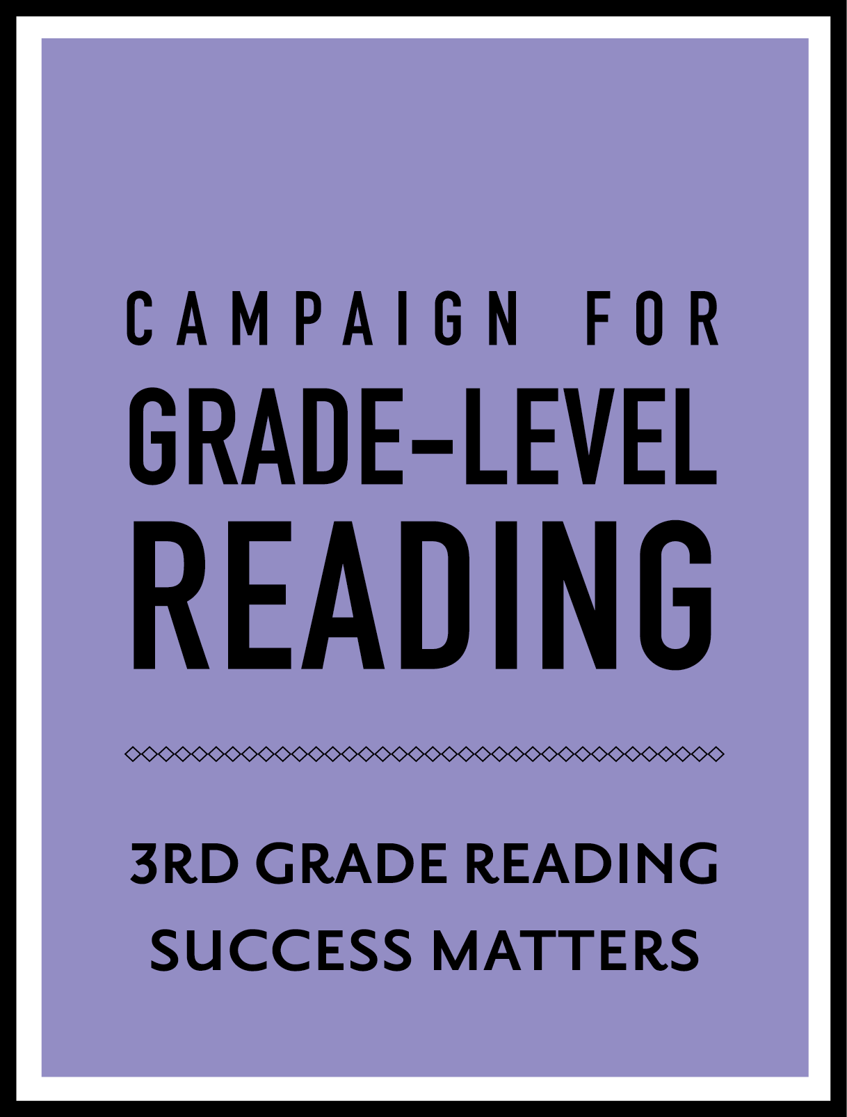
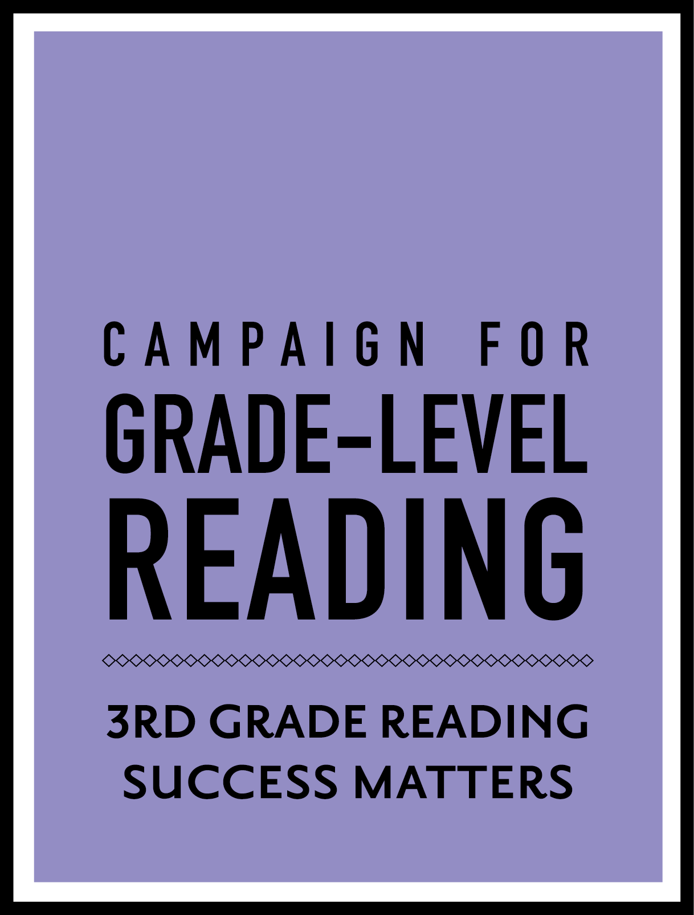
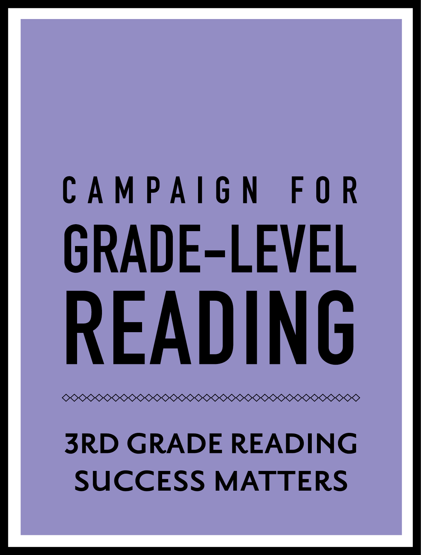
MILWAUKEE
CLEARFIELD,
KEARNS, PARK CITY,
& SOUTH SALT LAKE
SAHUARITA AND
GREEN VALLEY


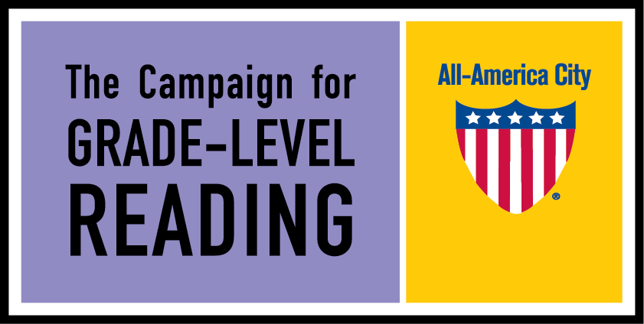
CLEARFIELD, KEARNS,
PARK CITY AND
SOUTH SALT LAKE
MILWAUKEE
SAHUARITA AND
GREEN VALLEY

